**JSS MAHAVIDYAPEETHA**



**Mini Project / Internship Assessment**

*“****Image Compressor****”*

|  |
| --- |
| **Subject Name: Mini-project / Internship Assessment**  **Subject Code: KCS-354** |

COURSE: B.Tech.

SEMESTER: IIIrd

**By**

Prasandeep

**Department of Computer Science and Engineering**

**JSS ACADEMY OF TECHNICAL EDUCATION**

**C-20/1, SECTOR-62, NOIDA**

**VISION AND MISSION**

**VISION OF THE INSTITUTE**

**JSS** **A**cademy of **T**echnical **E**ducation Noida aims to become an Institution of excellence in imparting quality **O**utcome **B**ased **E**ducation that empowers the young generation with **K**nowledge, **S**kills, **R**esearch, **A**ptitude, and **E**thical values to solve **Contemporary Challenging Problems.**

**MISSION OF THE INSTITUTE**

**D**evelop a platform for achieving a globally acceptable level of intellectual acumen and technological competence

**C**reate an inspiring ambiance that raises the motivation level for conducting quality research

**P**rovide an environment for acquiring ethical values and a positive attitude

**VISION OF THE DEPARTMENT**

“To spark the imagination of the Computer Science Engineers with values, skills

and creativity to solve the real-world problems.”

**MISSION OF THE DEPARTMENT**

To inculcate creative thinking and problem-solving skills through effective teaching, learning and research.

To empower professionals with core competency in the field of Computer Science and Engineering.

To foster independent and lifelong learning with ethical and social responsibilities.

**PROGRAM OUTCOMES (POs)**

**Engineering Graduates will be able to:**

**PO1: Engineering knowledge**: Apply the knowledge of mathematics, science, engineering fundamentals, and an engineering specialization to the solution of complex engineering problems.

**PO2: Problem analysis**: Identify, formulate, review research literature, and analyze complex engineering problems reaching substantiated conclusions using first principles of mathematics, natural sciences, and engineering sciences.

**PO3: Design/development of solutions**: Design solutions for complex engineering problems and design system components or processes that meet the specified needs with appropriate consideration for the public health and safety, and the cultural, societal, and environmental considerations.

**PO4: Conduct investigations of complex problems**: Use research-based knowledge and research methods including design of experiments, analysis and interpretation of data, and synthesis of the information to provide valid conclusions.

**PO5: Modern tool usage**: Create, select, and apply appropriate techniques, resources, and modern engineering and IT tools including prediction and modeling to complex engineering activities with an understanding of the limitations.

**PO6: The engineer and society**: Apply reasoning informed by the contextual knowledge to assess societal, health, safety, legal and cultural issues and the consequent responsibilities relevant to the professional engineering practice.

**PO7: Environment and sustainability**: Understand the impact of the professional engineering solutions in societal and environmental contexts, and demonstrate the knowledge of, and need for sustainable development.

**PO8: Ethics**: Apply ethical principles and commit to professional ethics and responsibilities and norms of the engineering practice.

**PO9: Individual and team work**: Function effectively as an individual, and as a member or leader in diverse teams, and in multidisciplinary settings.

**PO10: Communication**: Communicate effectively on complex engineering activities with the engineering community and with society at large, such as, being able to comprehend and write

effective reports and design documentation, make effective presentations, and give and receive clear instructions.

**PO11: Project management and finance**: Demonstrate knowledge and understanding of the engineering and management principles and apply these to one’s own work, as a member and leader in a team, to manage projects and in multidisciplinary environments.

**PO8: Ethics**: Apply ethical principles and commit to professional ethics and responsibilities and norms of the engineering practice.

**PO9: Individual and teamwork**: Function effectively as an individual, and as a member or leader in diverse teams, and in multidisciplinary settings.

**PO10: Communication**: Communicate effectively on complex engineering activities with the engineering community and with society at large, such as, being able to comprehend and write effective reports and design documentation, make effective presentations, and give and receive clear instructions.

**PO11: Project management and finance**: Demonstrate knowledge and understanding of the engineering and management principles and apply these to one’s own work, as a member and leader in a team, to manage projects and in multidisciplinary environments.

**PO12: Life-long learning**: Recognize the need for, and have the preparation and ability to engage in independent and life-long learning in the broadest context of technological change.

**PROGRAM EDUCATIONAL OUTCOMES (PEOs)**

**PEO1**: To empower students with effective computational and problem-solving skills.

**PEO2:** To enable students with core skills for employment and entrepreneurship.

**PEO3**: To imbibe students with ethical values and leadership qualities.

**PEO4:** To foster students with research-oriented ability which helps them in analyzing and solving real life problems and motivates them for pursuing higher studies.

**PROGRAM SPECIFIC OUTCOMES (PSOs)**

PSO1: An ability to apply the foundation of Computer Science and Engineering, algorithmic principles, and theory in designing and modeling computation-based systems.

PSO2: The ability to demonstrate software development skills.

**COURSE OUTCOMES (COs)**

|  |  |
| --- | --- |
| **C224.1** | Undertake problem identification, formulation, and design a solution |
| **C224.2** | Solve real-world problems effectively and adapt to a real-life working environment. |
| **C224.3** | Acquire skills and knowledge on latest tools and technologies |
| **C224.4** | Develop effective communication skills for presentation of project related activities |
| **C224.5** | Effectively communicate solution to problems through technical reports |

**CO-PO-PSO MAPPING**

|  |  |  |  |  |  |  |  |  |  |  |  |  |  |  |
| --- | --- | --- | --- | --- | --- | --- | --- | --- | --- | --- | --- | --- | --- | --- |
|  | **PO1** | **PO2** | **PO3** | **PO4** | **PO5** | **PO6** | **PO7** | **PO8** | **PO9** | **PO 10** | **PO 11** | **PO 12** | **PSO1** | **PSO2** |
| **C224.1** | 3 | 3 | 3 | 3 | 2 | 3 | 3 | 3 | 3 | 3 | 2 | 3 | 3 | 3 |
| **C224.2** | 3 | 3 | 3 | 3 | 3 | 3 | 3 | 3 | 3 | 2 | 3 | 3 | 3 | 3 |
| **C224.3** | 2 | 2 | 3 | 3 | 3 | 2 | 3 | 3 | 3 | 1 | 2 | 3 | 3 | 3 |
| **C224.4** | 2 | 2 | 2 | 2 | 2 | 2 | 2 | 2 | 2 | 3 | 2 | 3 | 2 | 2 |
| **C224.5** | 2 | 2 | 2 | 2 | 2 | 2 | 2 | 2 | 2 | 3 | 2 | 3 | 2 | 2 |
| **C224** | 2.40 | 2.40 | 2.60 | 2.60 | 2.40 | 2.40 | 2.60 | 2.60 | 2.60 | 2.40 | 2.20 | 3.00 | 2.60 | 2.60 |

***DECLARATION***

*I hereby declare that this submission is my own work and that, to the best of my knowledge and belief, it contains no material previously published or written by another person nor material which to a substantial extent has been accepted for the award of any other degree or diploma of the university or other institute of higher learning, except where due acknowledgment has been made in the text.*

***Signature:*** *Prasandeep*

***Name :***  *Prasandeep*

*Admission No. : 20DLCS003*

***Date :*** *24 Feb 2021*

## ***CERTIFICATE***

*This is to certify that Mini Project/Internship Assessment Report entitle “****Image Compressor****” which is submitted by* ***Prasandeep*** *in partial fulfillment of the requirement for the award of degree B. Tech. in Department of Computer Science and Engineering of Dr. APJ Abdul Kalam Technical University, Uttar Pradesh, Lucknow is a record of the candidate’s own work carried out by him/her under my supervision. The matter embodied in this report is original and has not been submitted for the award of any other degree.*

***Mentor: Mr. Harsha K.M***

***Date*** *: 23 Feb 2021*

***ACKNOWLEDGEMENT***

*I take this opportunity to express my profound gratitude and deep regards to my guide* ***Mentor: Mr. Harsha K.M*** *for his exemplary guidance, monitoring, and constant encouragement throughout the complete process of this project. The blessing, help, and guidance given by him from time to time shall carry me a long way in the journey of life on which I am about to embark.*

*I am obliged to staff members of JSS Academy of Technical Education, Noida, for the valuable information provided by them in their respective fields. I am grateful for their cooperation during the period of my assignment.*

*Lastly, I thank almighty, my parents, brother, sisters, and friends for their constant encouragement without which this assignment would not be possible.*

***Prasandeep [20DLCS003]***

**TABLE OF CONTENTS**

|  |  |  |
| --- | --- | --- |
| **Sr. No.** | **Title** | **Page No.** |
| **01** | **Declaration** | **06** |
| **02** | **Certificate** | **07** |
| **03** | **Acknowledgment** | **08** |
| **04** | **Introduction** | **10** |
| **05** | **Tools And Technology Used** | **11** |
| **06** | **History And Features Of Technology Used** | **16** |
| **07** | **Work done** | **21** |
| **08** | **Basic Workflow** | **30** |
| **09** | **Conclusion** | **31** |
| **10** | **Reference** | **32** |
| **11** | **Small SEO Tool-Plagiarism Report** | **33** |

**INTRODUCTION**

Everyone has a hobby to visit new places, hill stations, historical palaces and we also attend some important marriage parties. And we also captured images of their place for our best memories and we uploaded these images on social media and also wanted to store these images in our memory drive.

So these images have their high standard quality, images occupy the whole memory. Then an idea came to our mind that we can develop a cross platform software. And this software allows everyone to compress images without losing image quality. Because nowadays there are a lot of applications and web applications that compress images but they compress images with losing image quality. And in our application we compress the image. But we didn't lose the image quality. So that's why we think this idea can help every customer or user.

This application, developed in Python programming language and its GUI library 's name is PYQT5. And we have also used some OOPs concepts for making the readable and reusable code.

There are several GUI libraries in Python such as Tkinter, wxwidgets, GTK/GTK+ but here we have used only PYQt5 because it's the most powerful GUI library that allows us to develop cross-platform desktop applications. There are several applications written in PyQt5 and here, we have listed one example of a popular application that’s written in PyQt/PyQt5, **OpenShot** which is one of the most powerful video editing applications. And some other popular applications also written in PyQt5 like;- Orange, Spider, OpenLP, etc.

**Tools And Technology Used**

1. **Visual Studio Code**

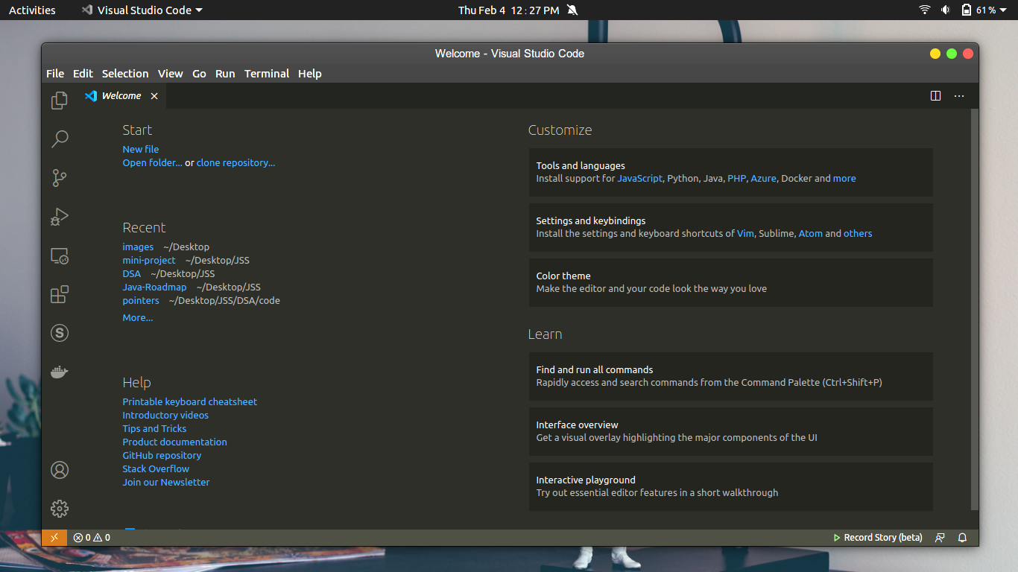

This is a view of visual Studio code when we don’t have any project or code file. So In this project we decided to use vs-code because this software has a lot of hidden features as compared to other softwares in the market such as sublime-text, Atom etc.

Visual Studio code is a Microsoft product, and it has different-different features like inbuilt code compilation, Terminal, Code testing, debugging etc. Visual studio code also supports Git. It has a lot of programming extensions, So when we code in any language such as python then It will give us an option to install Python3/Python2 extension for code execution. It has a lot of language support for coders and Software Developers.

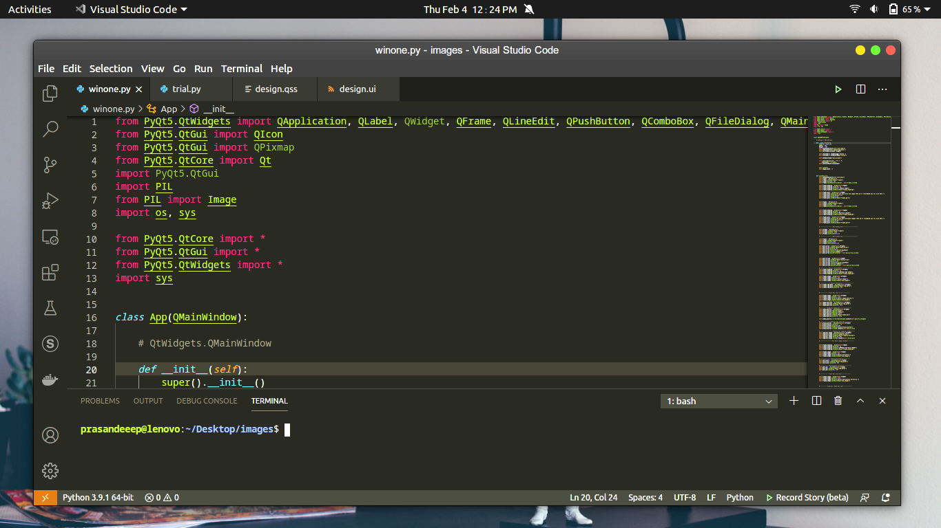

In this image we have written some code for our project, and here we have used the sublime text theme. So we can say that It's a powerful code editor.

**Written Language:**  C++, C#, Javascript, Typescript, HTML, CSS

**OS Support:** Linux, MacOS, Windows

**Language Support:** English (US), Simplified Chinese, Traditional Chinese, French, German, Italian, Portuguese (Brazil), Japanese, Korean, Russian, Spanish

**Why VS-Code?**

Visual Studio Code offers a lot of developer tools like debugging, code compilation/execution, powerful feature and simple environment. And one more thing is that it's available for cross platforms. Visual Studio Code support all common programming language like Python, Java, C++,C#, HTML,CSS, javaScript etc. There are also some alternative software instead of vscode like Pycharm, Atom etc.

**Python**

Python is a high-level, general-purpose interpreted programming language. It is the most popular and top programming language in the current IT industry. Its syntax is similar to the English language and it has very simplicity in the code, So we can

read and code easily without any syntax difficulty. Python supports object-oriented programming concepts and functional programming as well.

Now everywhere and in every field we can see the uses of Python programming language such as machine learning, Artificial Intelligence, web development, and data science. And it has a lot of rich libraries to solve our real-time problems.

In this project, we have used some Python libraries for developing image compressor desktop applications using some python libraries.

**PIP in Python**

PIP is a package manager for Python. It is allowed to use and install additional libraries in Python which is not available in Core python. So, using PIP we can install additional libraries. Pip is a standard package manager, for example, you have seen many times that javascript has npm package manager and Ruby has its own gem package manager.

Whenever, we need some Python library then we use the PyPi website with pip command.

**PIL Module in Python**

PIL is an image library in Python, It is also known as pillow. PIL library is used to manipulate images in different file formats. Basically it is an open source python3 library. In our project we have this library for manipulating and compressing images. This library is used for compressing images without losing image quality.

**PyQt/Qt5**

PyQT is a cross-platform Python GUI Library. It is used for creating GUI applications for desktop and embedded applications. It is both an open source and commercial library in python. This is a library we have because It has great features and interactive UI. It is written in Python and C++ programming language, So It has faster execution then other python libraries like Tkinter etc.

**Code Example :**

Here we have written some code for a simple Hello World! GUI application.

import sys

from PyQt5.QtWidgets import QApplication, QWidget, QLabel

from PyQt5.QtGui import QIcon

from PyQt5.QtCore import pyqtSlot

*def* window():

app = QApplication(sys.argv)

widget = QWidget()

textLabel = QLabel(widget)

textLabel.setText(

"\t\tWelcome To\nJSS Academy Of Technical Education,Noida")

textLabel.move(110, 85)

widget.setGeometry(50, 50, 320, 200)

widget.setWindowTitle("PyQt5 Example")

widget.show()

sys.exit(app.exec_())

if __name__ == '__main__':

window()

In the above picture, you can see the code of our first GUI application.

**Canva Graphics**

Canva is a great tool for creating and designing images, graphics and poster presentations etc. It is a web application and most demandable in the current market scenario. In our project, we have used it for designing background images for our application.

In the below picture, we can canvas for design images and graphics UI etc.

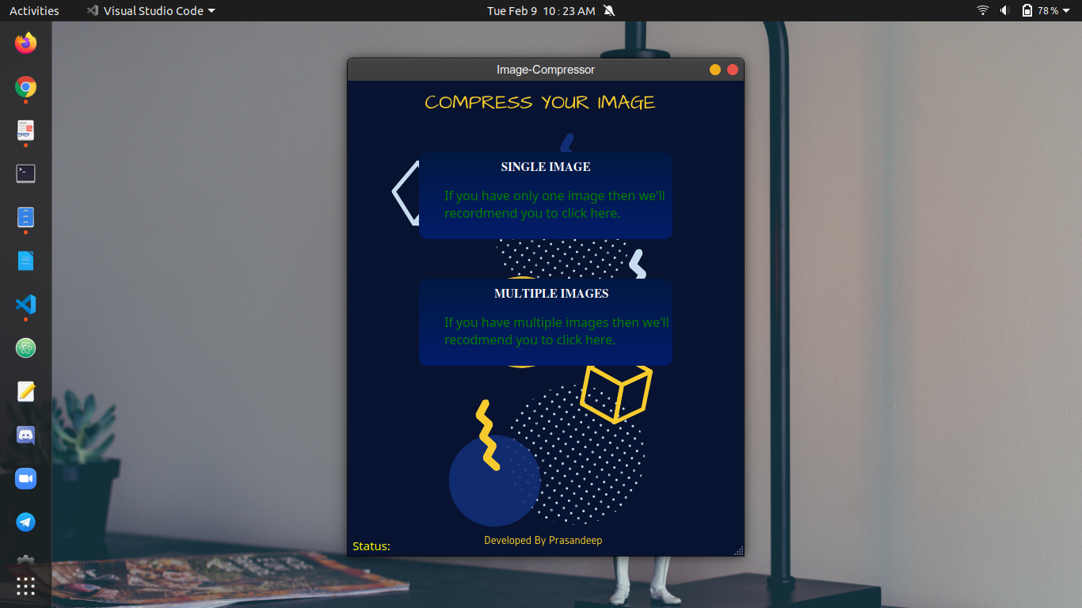

We can see in the above picture we have used canvas designed images in the background.

And Canva has different features to design and create images with new illustrations and add some new trending technologies icons in our images.

In this application we have also used a qss file, It is basically similar to css in web development. So the designing part is prepared by qss file.

**History And Features Of Technology Used**

**Visual Studio Code**

It is a free source-code editor developed by Microsoft Corporation. It is available for Windows, macOS and Linux. VS Code initially released on 29 April 2015. It supports all major features such as debugging syntax, highlighting, intelligent code completion, snippets etc. It is an embedded Git editor that helps users can change the theme, keyboard shortcuts.

Out-of-the-box, Visual Studio Code includes basic support for most common programming languages. This basic support includes syntax highlighting, bracket matching, code folding, and configurable snippets. Visual Studio Code also ships with IntelliSense for JavaScript, TypeScript, JSON, CSS, and HTML, as well as debugging support for Node.js. Support for additional languages can be provided by freely available extensions on the VS Code Marketplace

It developed in C++, javascript, electron, HTML,CSS and C# So it supports all programming languages. So visual studio code offers developers to code in various coding languages without any issue.

**History Of Python Programming Language**



*Guido van Rossum*

Python was conceived in the late 1980s by Guido van Rosssum, at Centrum Wiskunde & Informatica(CWI) in Netherlands as a successor to ABC programming language. Guido van Rosssum inspired by SETL, It is a high level programming language based on the mathematical theory of sets. And on 16 October 2000, Python 3.0 was released with major new features including a cycle-detecting garbage collector and support for unicode.

Python 3.0 was released on 3 December 2008. It was a major revision of the language that is not completely backward-compatible.

**Design and Features Of Python**

Python is a multi-paradigm programming language and it also supports object oriented programming features. It is fully supported and many of its features are functional programming.

Python uses dynamic typing and a combination of reference counting and a cycle-detecting garbage collector for memory management.

Python’s design offers some support for functional programming in the Lisp tradition. It has a filter, map, and reduce function list comprehensions, dictionaries, sets and generator expressions. And It’s standard library has two modules one is itertools and second is functools that implement functional tools.

The language’s core philosophy is summarized in the document The Zen of Python (PEP 20), which includes memorable expressions such as -

The Zen of Python, by Tim Peters -

Beautiful is better than ugly.

Explicit is better than implicit.

Simple is better than complex.

Complex is better than complicated.

Flat is better than nested.

Sparse is better than dense.

Readability counts.

Special cases aren't special enough to break the rules.

Although practicality beats purity.

Errors should never pass silently.

Unless explicitly silenced.

In the face of ambiguity, refuse the temptation to guess.

There should be one-- and preferably only one --obvious way to do it.

Although that way may not be obvious at first unless you're Dutch.

Now is better than never.

Although never is often better than *right* now.

If the implementation is hard to explain, it's a bad idea.

If the implementation is easy to explain, it may be a good idea.

Namespaces are one honking great idea -- let's do more of those!

These above lines are listed in Python, we can see these python design principle using import this module -

prasandeeep@lenovo:~$ python3

Python 3.8.5 (default, Jul 28 2020, 12:59:40)

[GCC 9.3.0] on linux

Type "help", "copyright", "credits" or "license" for more information.

>>> import this

**PyQt5/ PyQt**

PyQt is a Python binding of the cross-platform GUI toolkit Qt, implemented as a Python plug-in. ... It is available under similar terms to Qt versions older than 4.5; this means a variety of licenses including GNU General Public License (GPL) and commercial license, but not the GNU Lesser General Public License (LGPL).

It is developed by the **British firm Riverbank Computing**. Pyqt is based set of C++ libraries and development tools that include platform-independent abstractions for Graphical User Interfaces. It is developed by the **British firm Riverbank Computing**.

**Canva**

Canva is a graphic design platform, used to create social media graphics, presentations, posters, documents and other visual content. The app already includes templates for users

to use. The platform is free to use and offers paid subscriptions like Canva Pro and Canva for Enterprise for additional functionality.

Canva is a Sydney,Australian based graphic design platform which was developed by Melanie Perkins, Cliff Obrecht, Cameron Adams in 2012.

**Work Done**

1.First of all we will open the visual studio code and then we run some basic python commands like -

$ python3 image_comp.py

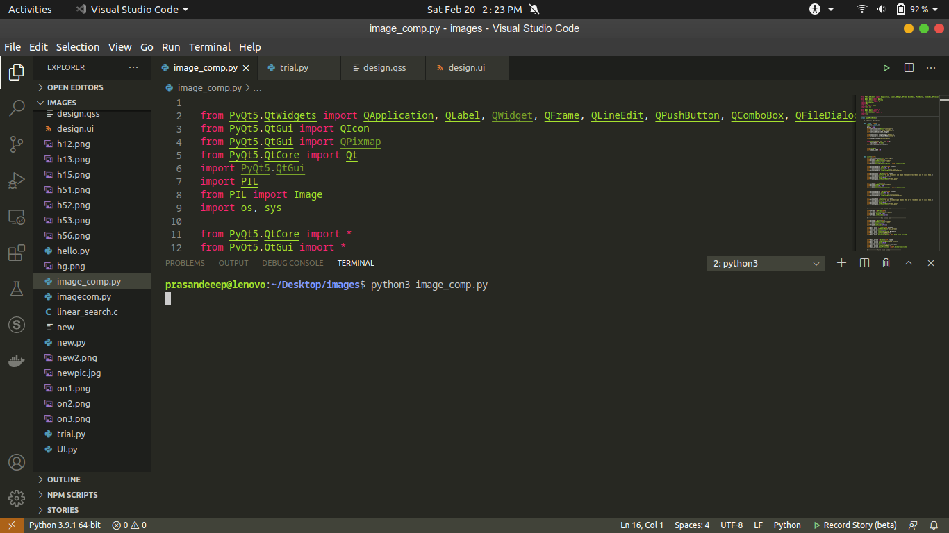

Now, we can see in the above picture our command is running successfully, after that we will get a interface of our application -

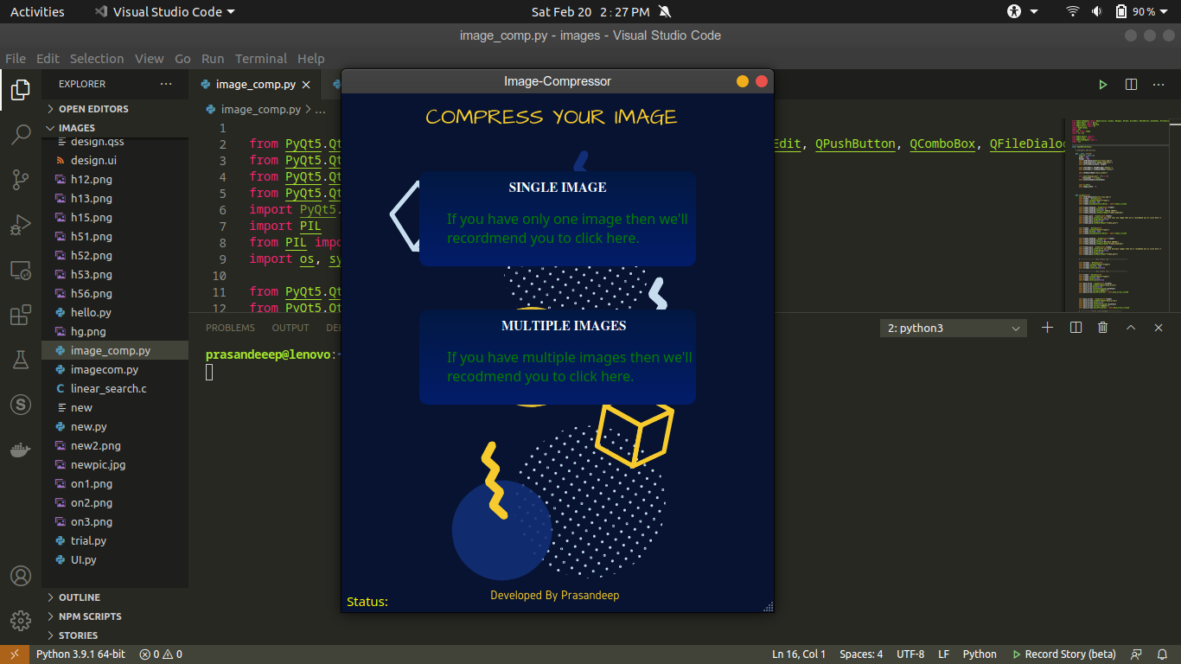

**For Single Image**

2. Now we have an option in this application,the first one is for compressing only one image at one time and the second one is for compressing multiple images at one time.

So if we need only one image to compress at one time then we will select the first button, and after we will get another window in this application.

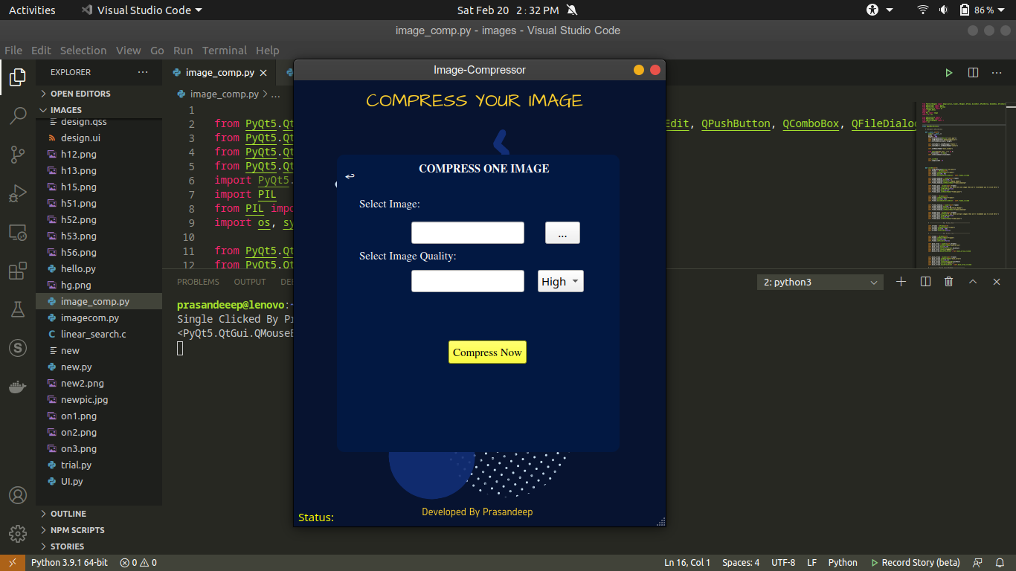

3. In this step we get a new interface after pressing on the first option or first button. Now, we can see here if we need to compress only one image then we will perform operation on this window.

4. In this step we will click on the ‘select image:’ ‘...’ button then will also select image quality.

There are three qualities of images, High, Medium, Low, So if you need medium quality then we will choose medium option and if we need low quality then we will choose low option. We can see also in the given picture here -

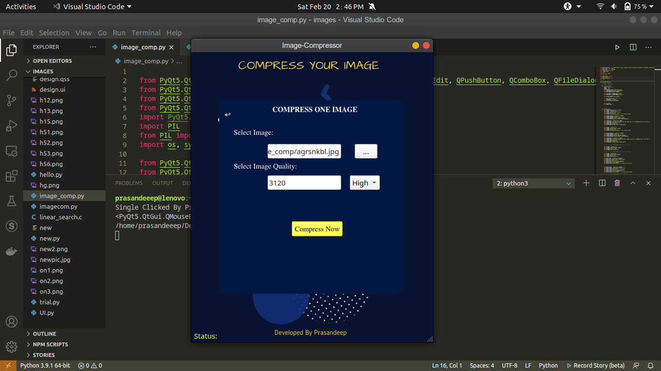

In the above picture we can see that our application fetches image width or quality when we select the image.

And there are three options but we choose only medium options here.

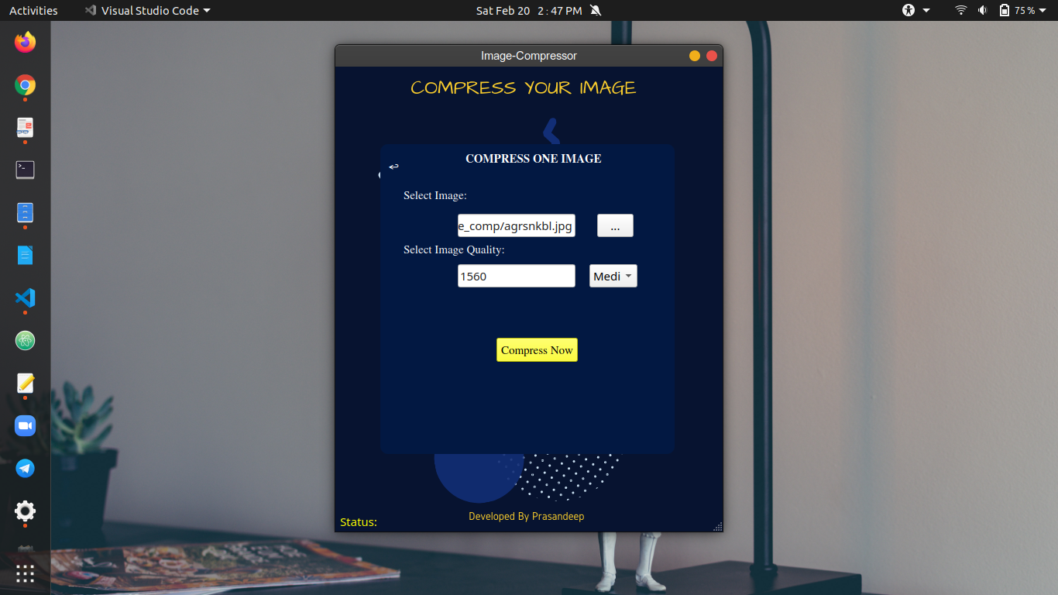

4. Now we will perform the image compressing feature, So we need to just click on the ‘Compress Now’ yellow button. Then we will get a pop-up to save the image as a new name, just like the given picture.

And we need to just write a name and and click on the ‘OK’ option and the image will be saved automatically.

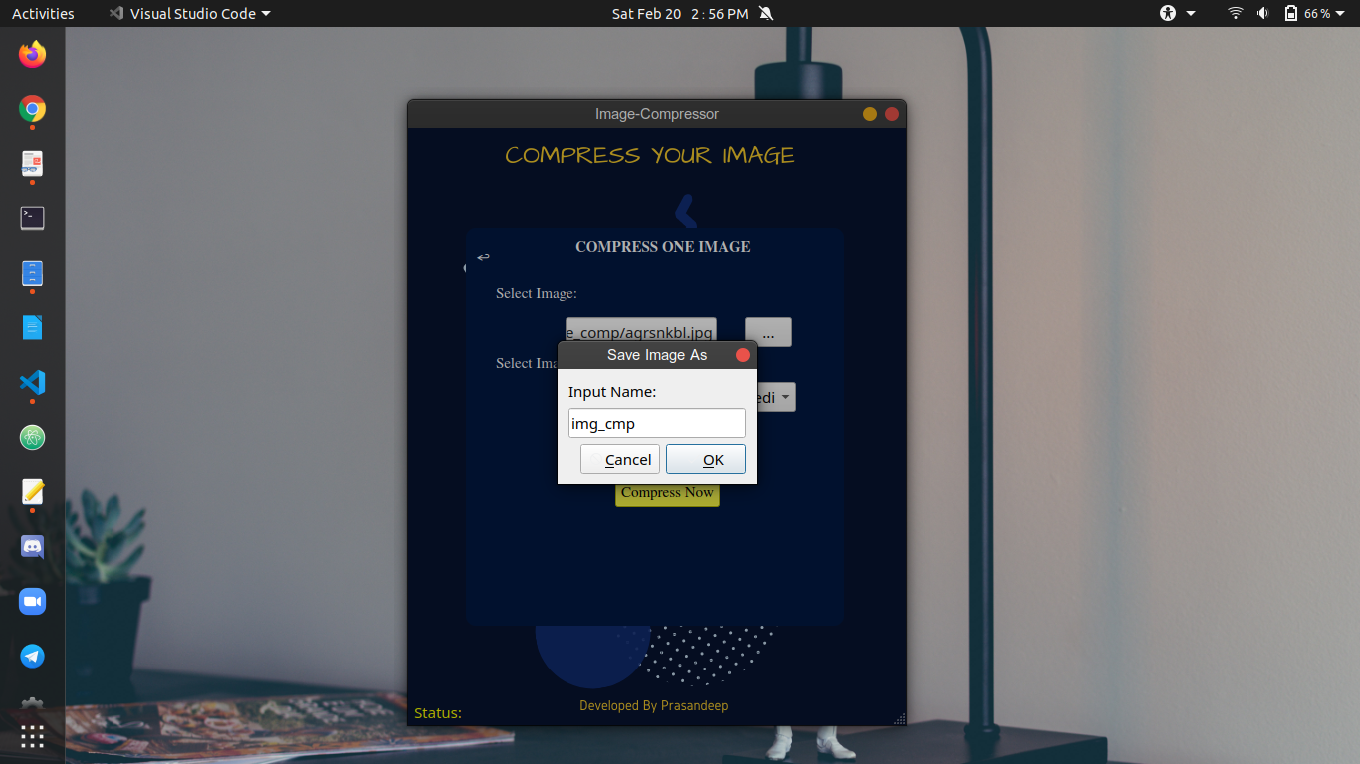

5. In this step we will reveal the image quality and pixels -

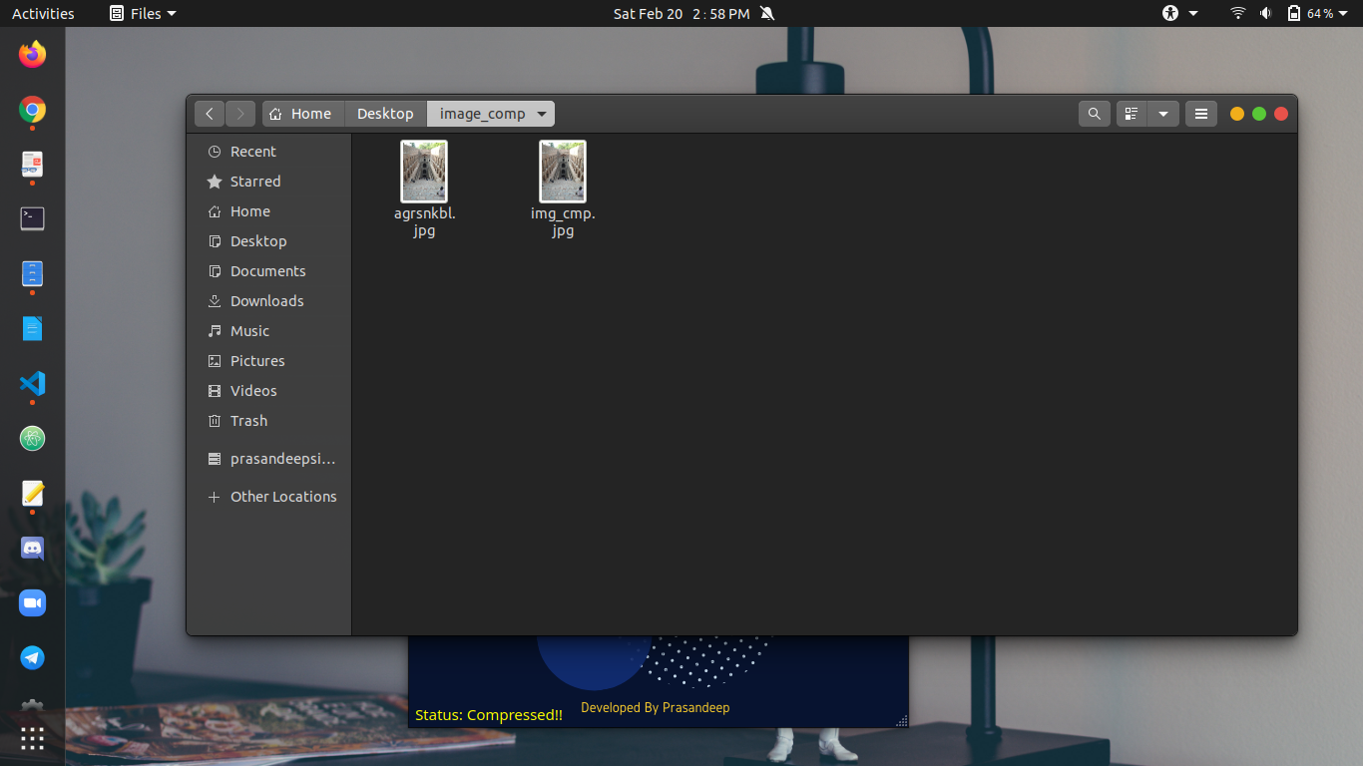

We can see in the above picture, now we have two pictures. The second one is our new compressed picture and the name is the same as we gave at the image compressing time.

6. Now It's time to check image pixels and image size, quality -

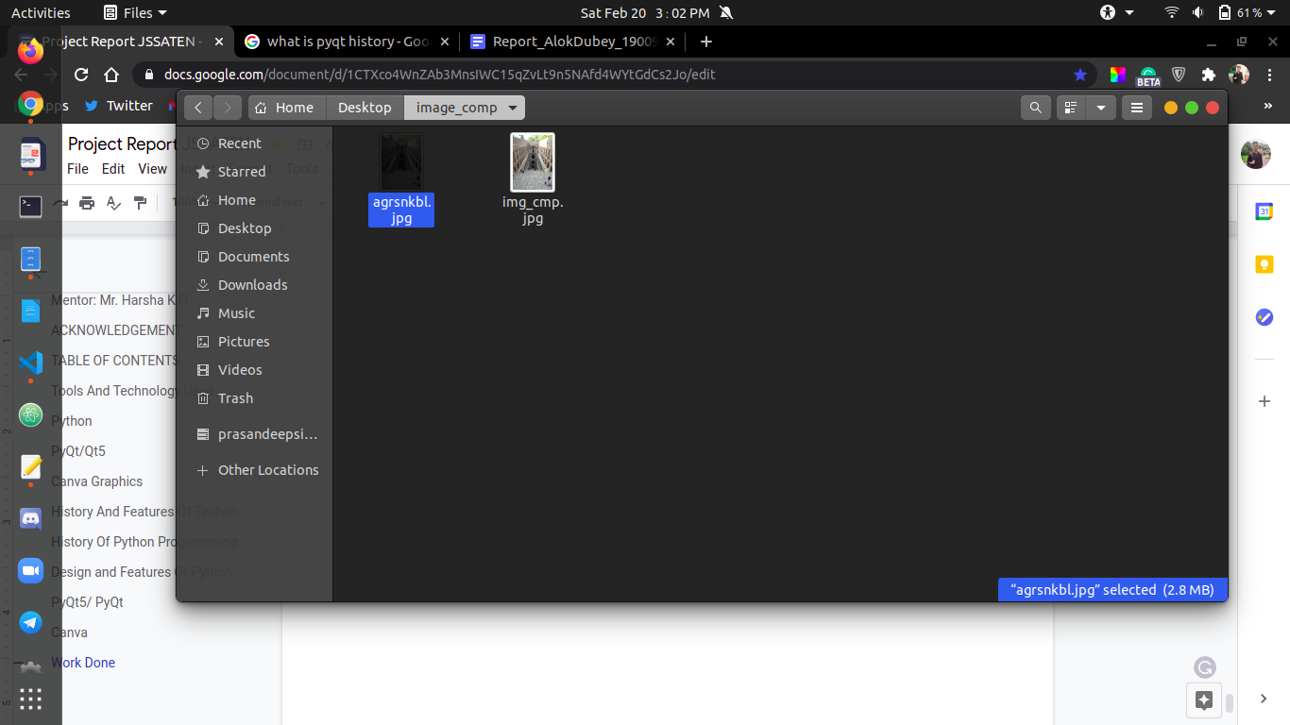

We can see in this picture, that our first image has 2.8 MB size -

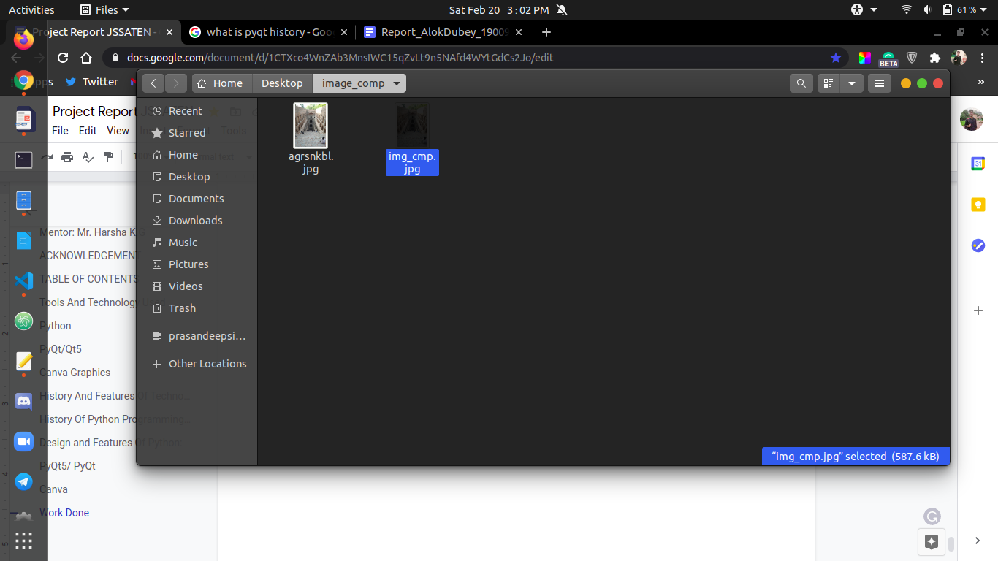

Now In this picture we can see that, this image has only 587.6KB after performing image compressing operation.

7. In this step we will check the image pixels and quality after viewing both images -

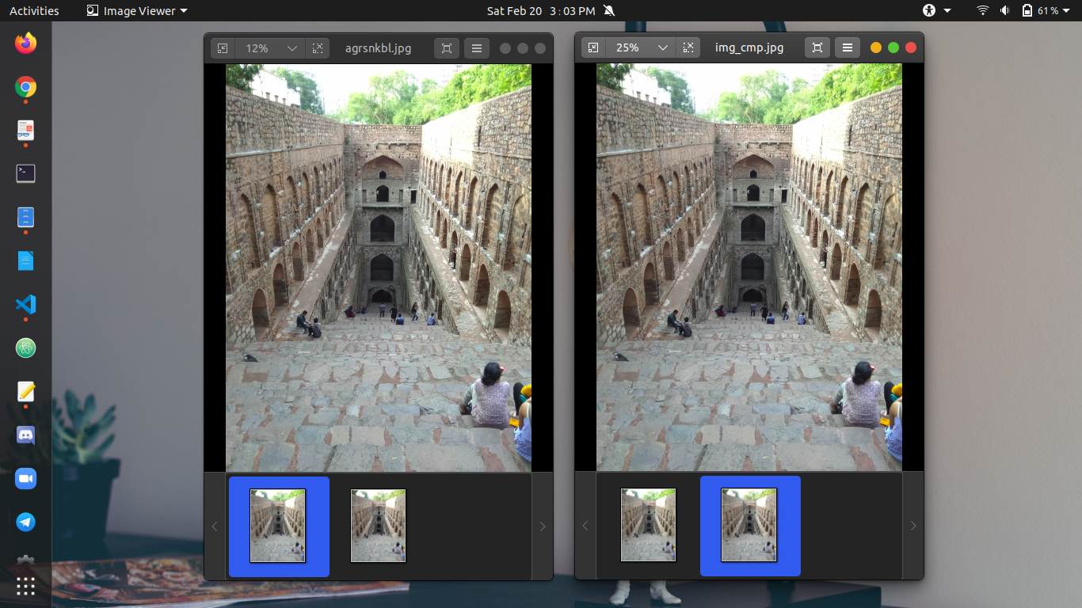

Here,we can see, both are the same images. There is no difference in pixels and quality.

**For Multiple Images**

For the multiple images we will select on the second button, just like in this image -



Now, we will select on the ‘Multiple Images’ button and we’ll get another window for performing image compression on the multiple images.

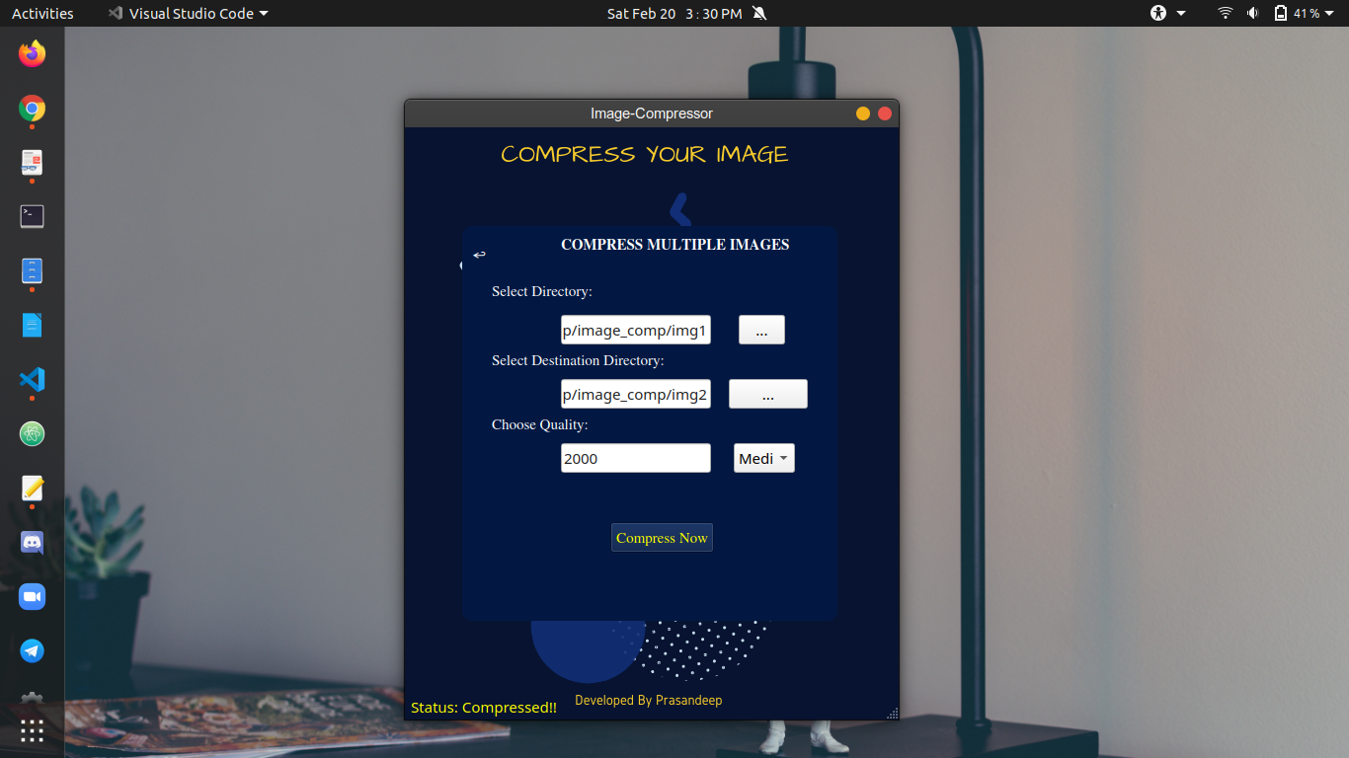

Now, we need to perform the operation after selecting the image from the directory path. So now it's time to click on the ‘Compress Now’ button. And then we will get our compressed images.

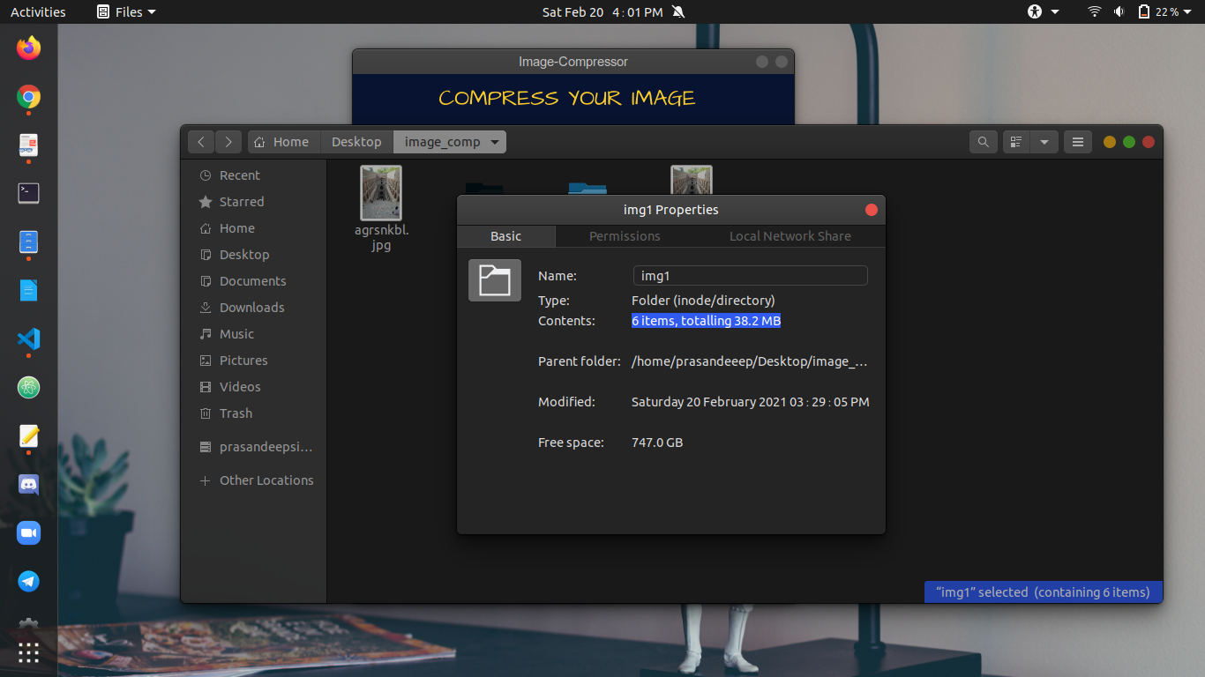

In the above picture we can see the total image size is 38.2 MB and there are a total 6 images.

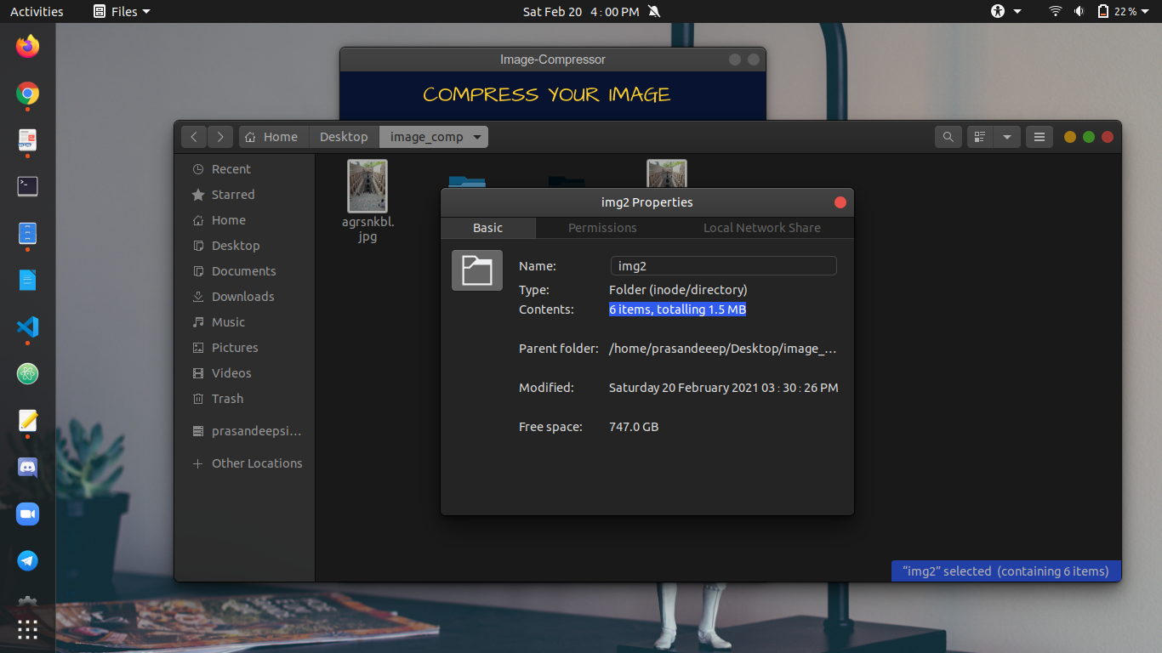

After compressing images we have saved images in the new folder so we can see the optimized images in there, the total size of images is 1.6 MB. So we can say that in our application both features are working properly.

**Basic Workflow**

The workflow of our application is divided into some steps, so we will discuss every step one by one.

**Step 1:** First of all we will open visual studio code because we have python code in this code editor.

**Step2:** In this step we will open our project folder and then will open project application file food eg;-”comp_img.py”.

**Step3:** In this step we will open the terminal in visual-studio code because we need to run our project code in the terminal.

**Step4:** After running our code we have successfully launched our application and now we need to perform image compression operation.

**Step5:**  After compressing the image with both options, we will check our images quality and pixels.

**Step6:** End

**Conclusion**

Python is a renowned programming language which has been in the industry for more than 25 years. Since its inception , it has gone through many updates and improvisations. Hence, Python is one of the fastest growing programming languages in the world.

Python is clear, simple, fast, reliable, flexible and scalable. As a fully-equipped with customisable architecture, it encourages quick development and simple code structure. Python is a very powerful programming language and it can be used for any purpose whether it be web application, machine learning, deep learning or artificial intelligence.

It can be used for any purpose just because of the large number of libraries present in it which are very useful, powerful and easy to use. Our project can be used on any operating system after pipelining. It can work very efficiently and fast also. It uses many libraries that are very powerful and efficient.

Python is very suitable for this because developers of python keep updating it and are making it day by day more easy and efficient so that beginners can learn the most powerful language easily. The demand of Desktop Applications, Machine learning Engineers and Data Analyst and Artificial Intelligence

Engineers are increasing exponentially and python is the most popular language among

these personals.

**References**

Stackoverflow - <https://stackoverflow.com/>

Python3 Official Website - https://www.python.org/download/releases/3.0/

PyPI - The Python Package Index - https://pypi.org/

RiverBankComputing - https://riverbankcomputing.com/software/pyqt/intro

Doc Qt - https://doc.qt.io/

PythonSpot - https://pythonspot.com/

**Small SEO Tool-Plagiarism Report**

